DS-LAB 2

22K-5195

**Q1.**

import java.util.Scanner;  
  
public class Q1 {  
 public static void main(String[] args) {  
 int a[] = new int[7];  
 int odd[];  
 int even[];  
 System.*out*.println("Enter the numbers: ");  
 for (int i = 0; i < a.length; i++) {  
 System.*out*.println("Element " + (i + 1));  
 Scanner s = new Scanner(System.*in*);  
 a[i] = s.nextInt();  
 }  
 int e=0;  
 int o=0;  
 for (int i = 0; i < a.length; i++) {  
  
 if (a[i] % 2 == 0) {  
 e++;  
 } else {  
 o++;  
 }  
 }  
 even=new int[e];  
 odd=new int[o];  
 int evencount=0;  
 int oddcount=0;  
  
 for (int i = 0; i < a.length; i++) {  
  
 if (a[i] % 2 == 0) {  
 even[evencount++] = a[i];  
 } else {  
 odd[oddcount++] = a[i];  
 }  
 }  
 for(int i=0;i<a.length;i++){  
 System.*out*.print(a[i]);  
 }  
 System.*out*.println("\n");  
 for(int i=0;i<even.length;i++){  
 System.*out*.print(even[i]);  
 }  
 System.*out*.println("\n");  
 for(int i=0;i<odd.length;i++){  
 System.*out*.print(odd[i]);  
 }  
 }  
}

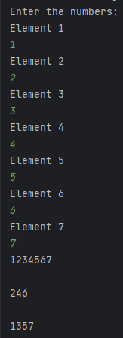

**Q2.**

import java.util.Scanner;  
  
public class Q2 {  
 public static void main(String[] args) {  
 int a[]=new int[5];  
 int b[]=new int[5];  
 int c[];  
 int similarcount=0;  
 System.*out*.println("Input elements of 1st array: ");  
 for(int i=0;i<a.length;i++){  
 Scanner s=new Scanner(System.*in*);  
 a[i]=s.nextInt();  
 }  
 System.*out*.println("Input elements of 2nd array: ");  
 for(int i=0;i<b.length;i++){  
 Scanner s=new Scanner(System.*in*);  
 b[i]=s.nextInt();  
 }  
 for(int i=0;i<a.length;i++){  
 for (int j=0;j<b.length;j++){  
 if(a[i]==b[j]){  
 similarcount++;  
 }  
 }  
 }  
 c=new int[similarcount];  
 int x=0;  
 for(int i=0;i<a.length;i++){  
 for (int j=0;j<b.length;j++){  
 if(a[i]==b[j]){  
 c[x++]=a[i];  
 }  
 }  
 }  
 for(int i=0;i<c.length;i++){  
 System.*out*.print(c[i] );  
 }  
 }  
}

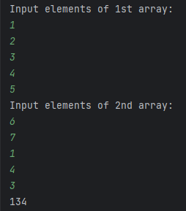

**Q3.**

public class Q3 {  
 public static void main(String[] args) {  
 Double[][] subjectScores = new Double[5][];  
 subjectScores[0] = new Double[]{3.21, 2.45, 4.0, 3.0, 3.75};  
 subjectScores[1] = new Double[]{3.75, 2.0, 0.0, 2.15, 0.0};  
 subjectScores[2] = new Double[]{3.45, 3.0, 0.0, 0.0, 0.0};  
 subjectScores[3] = new Double[]{4.0, 3.0};  
 subjectScores[4] = new Double[]{3.33, 2.75, 3.35, 3.98};  
  
 double[] GPAs = new double[5];  
  
 for (int i = 0; i < 5; i++) {  
 for (int j = 0; j < subjectScores[i].length; j++) {  
 GPAs[i] += subjectScores[i][j];  
 }  
 }  
  
 for (int i = 0; i < subjectScores.length; i++) {  
 GPAs[i] = ((GPAs[i] * 3) / (subjectScores[i].length * 3));  
 System.*out*.println(GPAs[i]);  
 }  
 }  
}

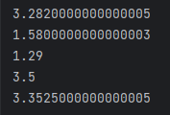

**Q4.**

import java.util.Scanner;  
  
public class Q4 {  
 public static void main(String[] args) {  
 int a[]=new int[6];  
 for(int i=0;i<a.length;i++){  
 System.*out*.println("enter element " + i);  
 Scanner s=new Scanner(System.*in*);  
 a[i]=s.nextInt();  
 }  
 int temp;  
 for(int i=0;i<a.length-1;++i){  
 for(int j=0;j<(a.length)-i-1;++j){  
 if(a[j]>a[j+1]) {  
 temp = a[j];  
 a[j] = a[j+1];  
 a[j+1] = temp;  
 }  
 }  
 }  
 for(int i=0;i<a.length;i++){  
 System.*out*.print(a[i]);  
 }  
 System.*out*.println("\n");  
  
 for(int i=0;i<a.length-1;i++){  
 for(int j=0;j<a.length-i-1;j++){  
 if((a[j]%2==0) && (a[j+1]%2!=0)){  
 temp=a[j];  
 a[j]=a[j+1];  
 a[j+1]=temp;  
 }  
 }  
 }  
 for(int i=0;i<a.length;i++){  
 System.*out*.print(a[i]+" ");  
 }  
 }  
 }

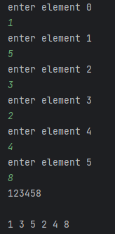

**Q5.**

import java.util.Scanner;  
  
public class Q5 {  
 public static void main(String[] args) {  
  
 System.*out*.println("Please provide the size of the array: ");  
 Scanner input = new Scanner(System.*in*);  
 int size = input.nextInt();  
 int array[] = new int[size];  
  
 for (int i = 0; i < size; i++) {  
 System.*out*.println("Enter element at index " + i + ": ");  
 array[i] = input.nextInt();  
 }  
  
 System.*out*.println("Initial array: ");  
 for (int num : array) {  
 System.*out*.print(num + " ");  
 }  
  
 for (int i = 0; i < size - 1; i++) {  
 for (int j = 0; j < size - i - 1; j++) {  
 if (array[j] < array[j + 1]) {  
 int temporary = array[j];  
 array[j] = array[j + 1];  
 array[j + 1] = temporary;  
 }  
 }  
 }  
  
 System.*out*.println();  
 System.*out*.println("Array before sorting: ");  
 for (int num : array) {  
 System.*out*.print(num + " ");  
 }  
  
 for (int i = 0; i < size - 1; i++) {  
 for (int j = 0; j < size - i - 1; j++) {  
 int temporary;  
 if (array[0] % 2 == 0) {  
 if ((array[j] % 2 != 0) && (array[j + 1] % 2 == 0)) {  
 temporary = array[j];  
 array[j] = array[j + 1];  
 array[j + 1] = temporary;  
 }  
 } else if ((array[j] % 2 == 0) && (array[j + 1] % 2 != 0)) {  
 temporary = array[j];  
 array[j] = array[j + 1];  
 array[j + 1] = temporary;  
 }  
 }  
 }  
  
 System.*out*.println();  
 System.*out*.println("Array after sorting: ");  
 for (int num : array) {  
 System.*out*.print(num + " ");  
 }  
 }  
}

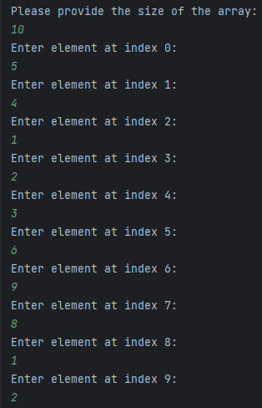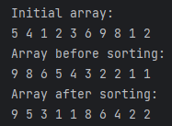

**Q6.**

import java.util.Arrays;  
import java.util.Scanner;  
  
public class Q6 {  
 public static void main(String[] args) {  
  
 System.*out*.println("Please provide the size of the array: ");  
 Scanner scanner = new Scanner(System.*in*);  
 int size = scanner.nextInt();  
 int array[] = new int[size];  
  
 for (int i = 0; i < size; i++) {  
 System.*out*.println("Enter element at index " + i + ": ");  
 array[i] = scanner.nextInt();  
 }  
  
 System.*out*.println("Original array: " + Arrays.*toString*(array));  
  
 boolean exchangeOccurred;  
  
 for (int i = 0; i < size; i++) {  
 exchangeOccurred = false;  
  
 for (int j = 0; j < size - i - 1; j++) {  
 if (array[j] > array[j + 1]) {  
  
 int temporary = array[j];  
 array[j] = array[j + 1];  
 array[j + 1] = temporary;  
 exchangeOccurred = true;  
 }  
 }  
 if (!exchangeOccurred) {  
 break;  
 }  
 }  
  
 System.*out*.println("Sorted array: " + Arrays.*toString*(array));  
 }  
}

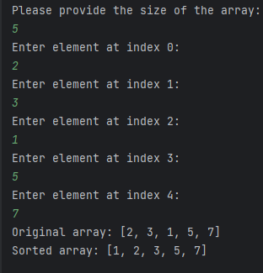

**Q7.**

public class Q7 {  
   
 public static void main(String[] args)  
 {  
 String[] arr = { "zebra", "apple", "banana", "grape", "date", "cherry" };  
 System.*out*.println("Original Array:");  
 for (int i = 0; i < arr.length; i++) {  
 System.*out*.print(arr[i] + " ");  
 }  
 System.*out*.println();  
 int n = arr.length;  
 *sort*(arr, n);  
 System.*out*.println("Sorted Array : ");  
 for (int i = 0; i < n; i++)  
 System.*out*.print(arr[i] + " ");  
 }  
 public static void sort(String[] arr, int n)  
 {  
 String temp;  
 for (int j = 0; j < n - 1; j++) {  
 for (int i = j + 1; i < n; i++) {  
 if (arr[j].compareTo(arr[i]) > 0) {  
 temp = arr[j];  
 arr[j] = arr[i];  
 arr[i] = temp;  
 }  
 }  
 }  
 }  
}

